Terraform Challenge

Write a code using Terraform that deploys and achieves the following:-
Create an EC2 Instance on AWS Cloud using the below-mentioned ubuntu AMI and instance_type. Or, (You can use of your choice as well) ami = "ami-0461b1436c9b3c1a3" instance_type = "t2.micro"
Install a web server on the same EC2 Instance. The web server should listen on port 8080.
- Create a Docker-compose file for the project: https://github.com/betawins/cricbuzz-docker-hello-world.git and point it to port 8000.
- Make the web server point to the above service so that 8080 returns the response from the Docker service.
- Configure to Save the Logs in the location /var/log/cb.log
- Write the Log rotate configuration for the above file.

Title
Provision an AWS EC2 Instance Using Terraform and Expose a Docker Application via Web Server on Port 8080

Objective
The objective of this task is to use Terraform to:
- Create an EC2 instance on AWS using an Ubuntu AMI.
- Install a web server (Nginx) that listens on port 8080.
- Deploy a Dockerized application using docker-compose on port 8000 from the GitHub repository:
https://github.com/betawins/cricbuzz-docker-hello-world.git
- Configure the web server as a reverse proxy so that:
  - Requests on port 8080 are forwarded to the Docker service on port 8000.
- Store web server logs at /var/log/cb.log.
- Configure log rotation for the above log file.

provider "aws" {
region = "eu-north-1"
}

resource "aws_key_pair" "cb_key" {
key_name = "cb-key"
public_key = file("~/.ssh/id_rsa.pub")
}

resource "aws_security_group" "cb_sg" {
name = "cb-sg"
description = "Allow SSH and app ports"

ingress {
from_port = 22
to_port = 22
protocol = "tcp"
cidr_blocks = ["0.0.0.0/0"]
}

ingress {
from_port = 8080
to_port = 8080
protocol = "tcp"
cidr_blocks = ["0.0.0.0/0"]
}

ingress {
from_port = 8000
to_port = 8000
protocol = "tcp"
cidr_blocks = ["0.0.0.0/0"]
}

egress {
from_port = 0
to_port = 0
protocol = "-1"
cidr_blocks = ["0.0.0.0/0"]
}
}

resource "aws_instance" "challenge" {
ami = "ami-073130f74f5ffb161"
instance_type = "t3.small"
key_name = aws_key_pair.cb_key.key_name
vpc_security_group_ids = [aws_security_group.cb_sg.id]

user_data = <<-EOF
#!/bin/bash
set -e
apt-get update -y
apt-get install -y docker.io docker-compose nginx git logrotate
systemctl enable docker
systemctl start docker
systemctl enable nginx
systemctl start nginx

cd /opt
rm -rf cricbuzz-docker-hello-world || true
git clone https://github.com/betawins/cricbuzz-docker-hello-world.git
cd cricbuzz-docker-hello-world

cat > docker-compose.yml <<EOL
version: "3.8"
services:
cb-app:
image: nginx:alpine
container_name: cb-app
ports:
- "8000:80"
restart: always
EOL

docker-compose up -d

rm -f /etc/nginx/sites-enabled/default

cat > /etc/nginx/sites-available/cb-proxy <<EOL
server {
listen 8080;
access_log /var/log/cb.log;
error_log /var/log/cb.log;
location / {
proxy_pass http://127.0.0.1:8000;
}
}
EOL

ln -s /etc/nginx/sites-available/cb-proxy /etc/nginx/sites-enabled/cb-proxy
systemctl restart nginx

cat > /etc/logrotate.d/cb-log <<EOL
/var/log/cb.log {
daily
rotate 7
compress
missingok
notifempty
}
EOL
EOF

tags = {
Name = "challenge"
}
}

output "ec2_public_ip" {
value = aws_instance.challenge.public_ip
}

Step-by-Step Implementation:

Step 1: Provider Configuration
provider "aws" {
region = "eu-north-1"
}
What this does
- Tells Terraform to use AWS
- Deploys resources in eu-north-1 (Stockholm) region

Step 2: Key Pair Creation
resource "aws_key_pair" "cb_key" {
key_name = "cb-key"
public_key = file("~/.ssh/id_rsa.pub")
}
What this does
- Uses your local SSH public key
- Creates an AWS key pair so you can SSH into EC2

Step 3: Security Group Configuration
resource "aws_security_group" "cb_sg" {
name = "cb-sg"
description = "Allow SSH and app ports"

Ingress rules:
- 22 → SSH access
- 8080 → Nginx reverse proxy
- 8000 → Docker application

Egress rule:
- Allows all outbound traffic
Why needed
- Without these rules, EC2 cannot be accessed or serve traffic

Step 4: EC2 Instance Creation

EC2 resource name changed to challenge
resource "aws_instance" "challenge" {
ami = "ami-073130f74f5ffb161"
instance_type = "t3.small"
key_name = aws_key_pair.cb_key.key_name
vpc_security_group_ids = [aws_security_group.cb_sg.id]
What this does
- Launches an Ubuntu EC2 instance
- Uses t3.small
- Attaches key pair and security group

Step 5: Software Installation (user_data)
apt-get update -y
apt-get install -y docker.io docker-compose nginx git logrotate
Installed components
- Docker & Docker-Compose → run container
- Nginx → web server / reverse proxy
- Git → clone repository
- Logrotate → log management

Step 6: Docker Application Setup (Port 8000)
git clone https://github.com/betawins/cricbuzz-docker-hello-world.git
Docker Compose file created:
version: "3.8"
services:
cb-app:
image: nginx:alpine
container_name: cb-app
ports:
- "8000:80"
restart: always
Result
- Docker app runs on port 8000

Step 7: Nginx Reverse Proxy (Port 8080 → 8000)
server {
listen 8080;
access_log /var/log/cb.log;
error_log /var/log/cb.log;

location / {
proxy_pass http://127.0.0.1:8000;
}
}
What this does
- Nginx listens on 8080
- Forwards traffic to Docker app on 8000
- Saves logs to /var/log/cb.log

Step 8: Log Rotation Configuration
/var/log/cb.log {
daily
rotate 7
compress
missingok
notifempty
}
Result
- Logs rotate daily
- Keeps 7 days
- Prevents disk overuse

Step 9: Tagging
tags = {
Name = "challenge"
}
Why
- Identifies EC2 instance in AWS console as challenge

Step 10: Output Public IP
output "ec2_public_ip" {
value = aws_instance.challenge.public_ip
}
Result
- Displays EC2 public IP after terraform apply

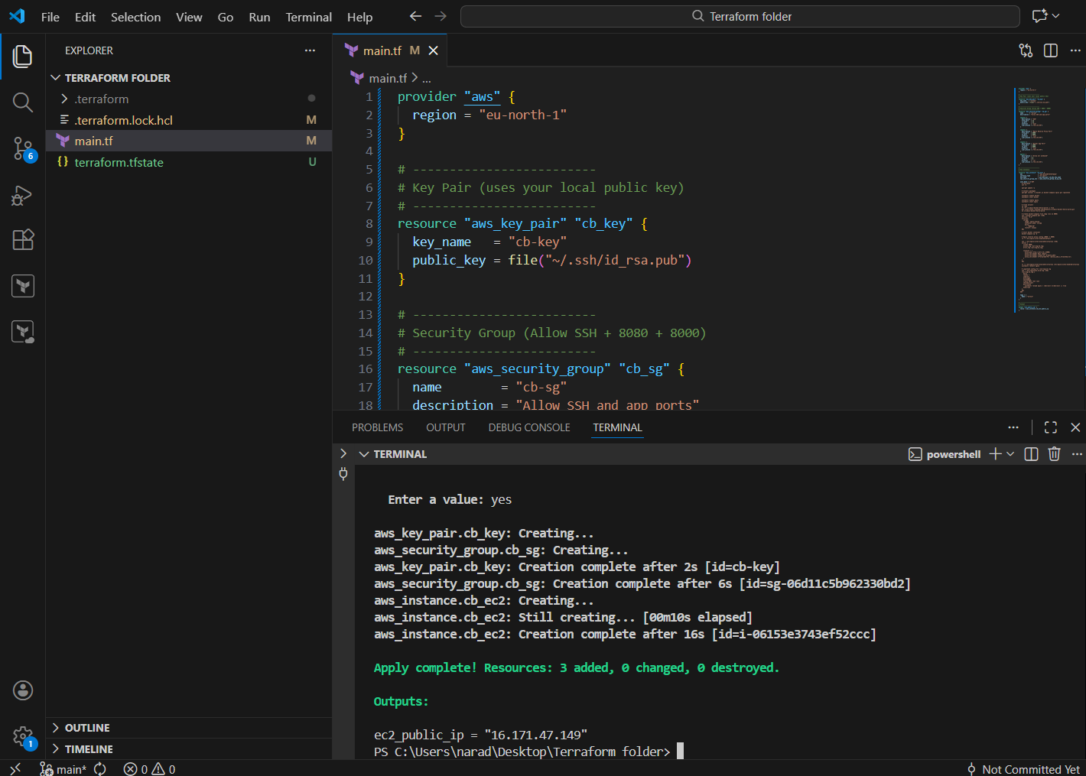

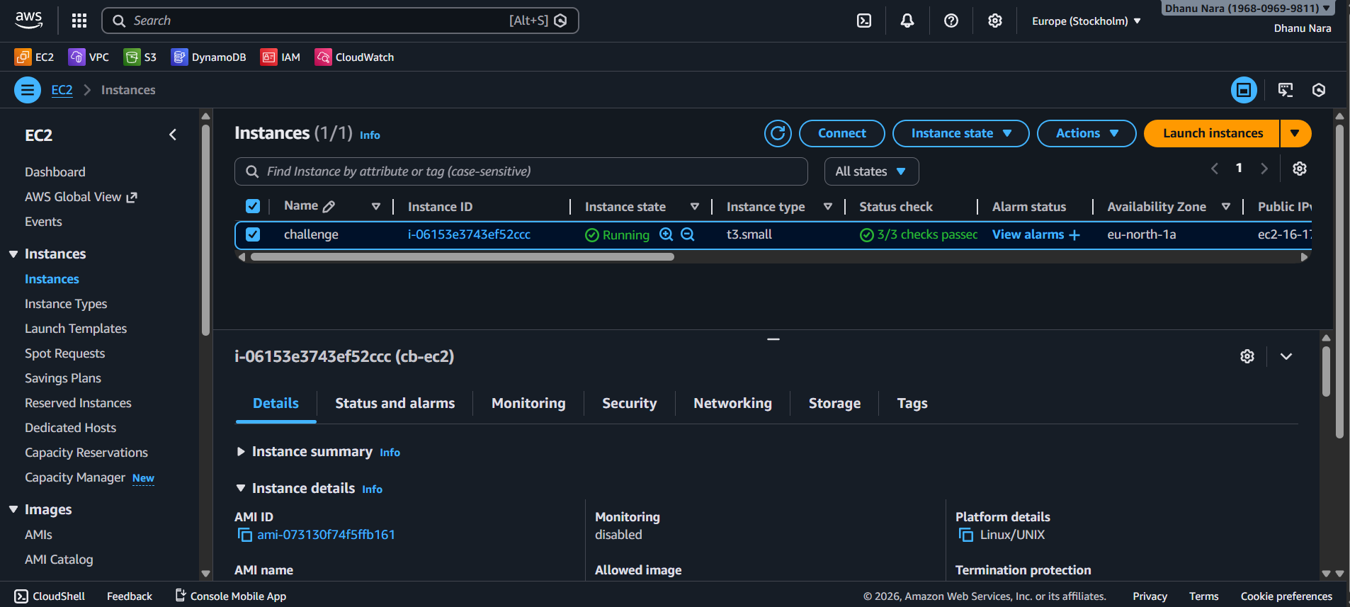

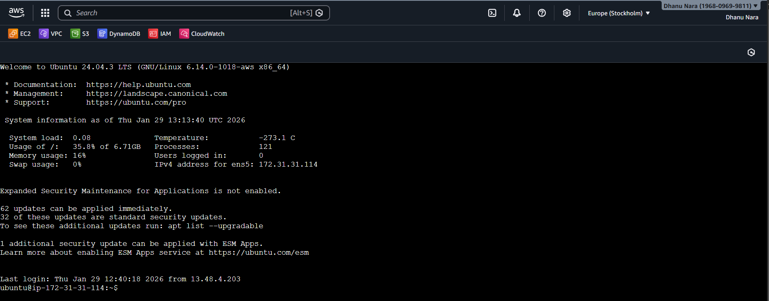

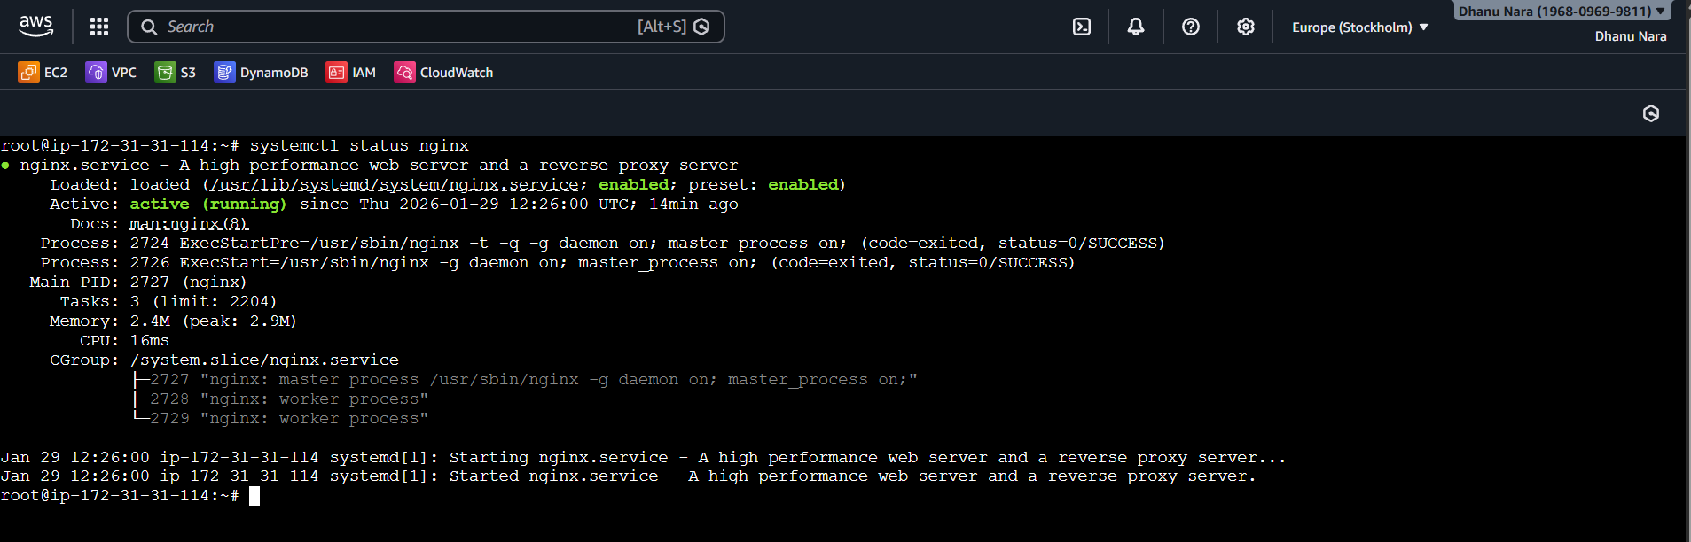

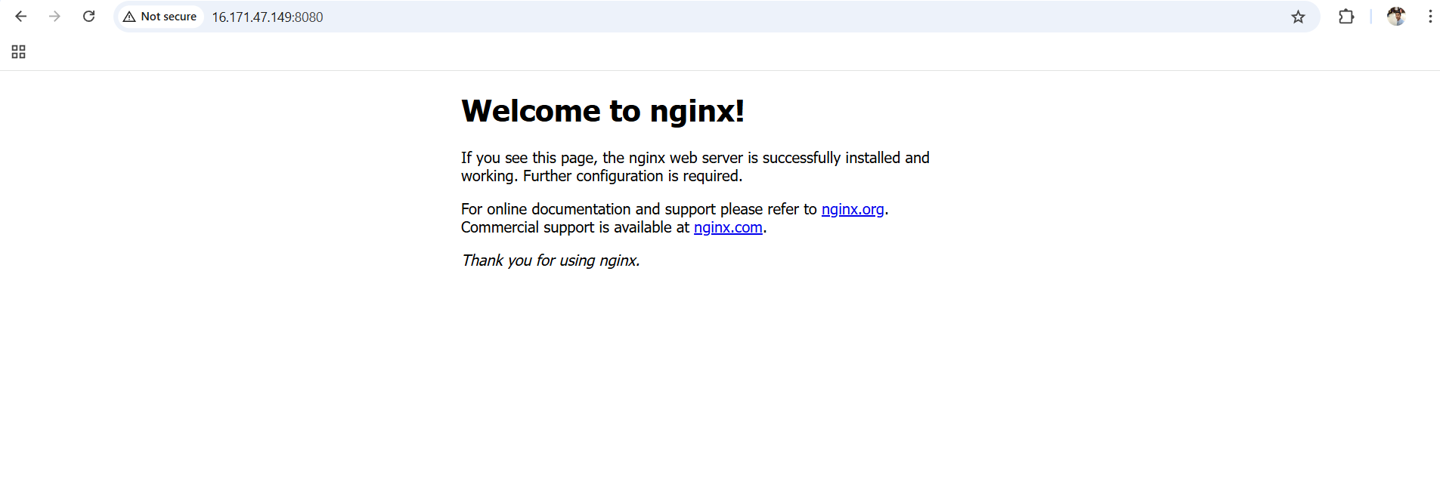

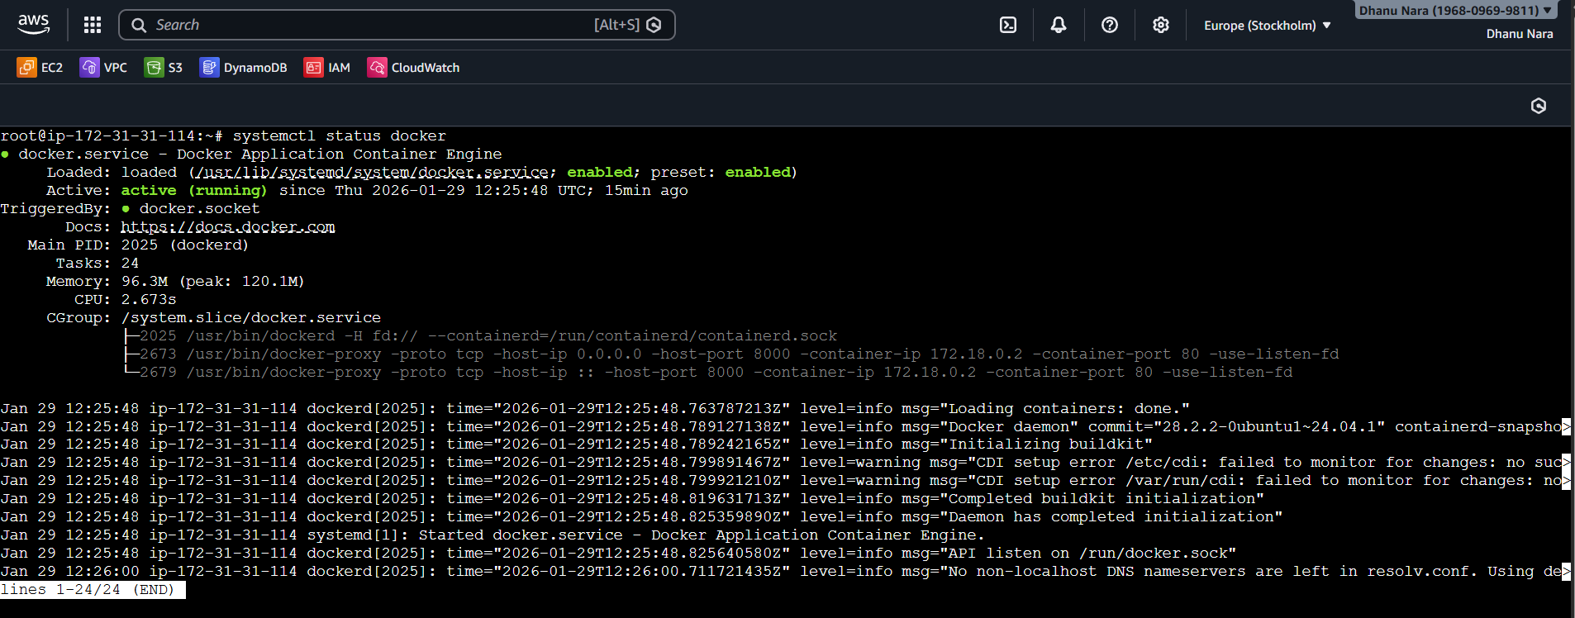

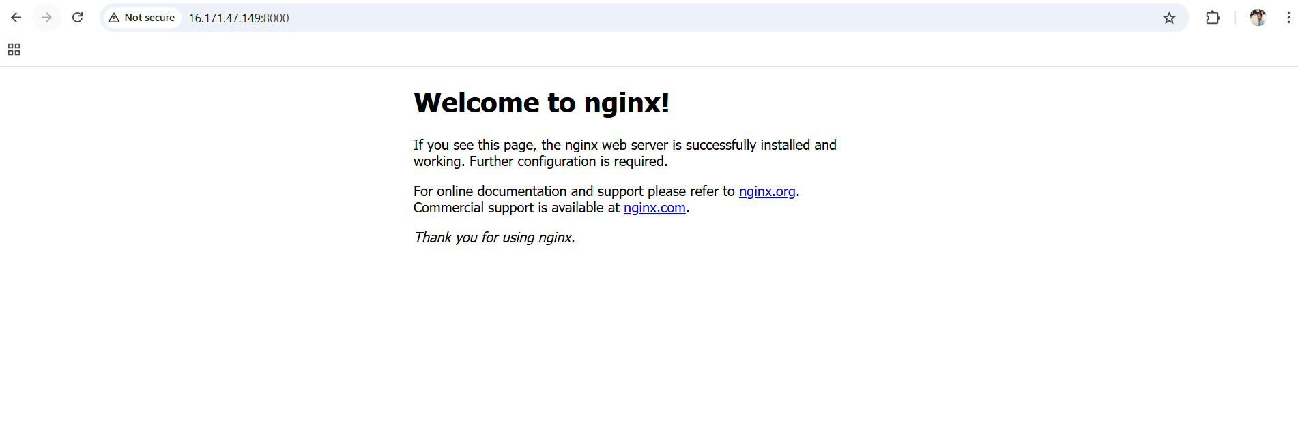

Conclusion
This Terraform solution successfully provisions an AWS EC2 instance, deploys a Dockerized application, and exposes it through a web server using a reverse proxy. Logging and log rotation ensure maintainability and operational stability. The setup follows infrastructure-as-code best practices and is fully automated, reproducible, and production-ready.

